SIMATS ENGINEERING

Department of Computer Science & Engineering
ASSESSMENT TOOL 2- DEBUGGING & OPTIMISATION TASK

Course Code: | CSA12 | Course Title: | Computer Architecture
CO Assessed: | CO2 | Assessment: | ASSESSMENT TOOL2-DEBUGGING & OPTIMISATION TASK
Weightage: | 20% | Total Marks: | 25
CO2 Statement: | Apply integer and floating-point arithmetic algorithms including Booth's multiplication, restoring/non-restoring division, and IEEE 754 standard operations to solve fixed-point and floating-point computational problems. (BL3)
Student Name: | YAZHINI.E.M | Reg.No.: | 192511165
Department: | B.E.CSE | Date: | 1/08/2026

ANNEXURE A
- A program performing signed integer addition using 2’s complement produces incorrect results when adding large values (e.g., +120 and +50 in 8-bit representation). Debug the issue by analyzing the binary computation and identifying whether overflow has occurred. Propose a solution to correctly detect and handle overflow in such cases.

- A processor using a ripple carry adder shows significant delay in executing arithmetic operations in a real-time system. Debug the performance bottleneck by examining how carry propagates through each bit. Suggest an optimized solution using a carry look-ahead adder, and explain how it reduces delay.

- A multiplication unit implementing Booth’s algorithm gives incorrect results for certain negative operands. Debug the step-by-step execution of the algorithm, focusing on bit-pair checking, arithmetic shifts, and sign extension. Identify the possible source of error and suggest corrections to ensure accurate signed multiplication.

- An embedded system using the restoring division algorithm experiences inefficiency due to repeated restoration steps, leading to increased execution time. Debug the algorithm’s workflow and identify where unnecessary operations occur. Propose an optimized approach using the non-restoring division method, explaining how it improves performance.

- A scientific application using IEEE 754 single precision floating-point representation produces inaccurate results when adding very small and very large numbers. Debug the issue by analyzing exponent alignment, normalization, and rounding errors. Suggest optimization techniques, such as using double precision or algorithmic adjustments, to improve accuracy.

Code of Conduct:

I YAZHINI.EM/192511165 (Name / Reg No) certify that this submission is my original work and that I have adhered to the guidelines specified for this assessment.I understand that any violation of academic integrity rules will result in disciplinary action.

Signature of the student:

MARKS ALLOCATION

 | Identification of Errors / Bugs  (20%) | Debugging Approach &  Analysis (20%) | Correctnes s of Debugged Solution  (25%) | Optimization Techniques Applied (20%) | Testing and Documentation (15%)
Q1
Q2
Q3
Q4
Q5

RUBRICS FOR CALCULATION:

Criteria | Weightage | Level 4 – Exemplary | Level 3 – Proficient | Level 2 – Developing | Level 1 – Beginning
Identification of Errors / Bugs | 20% | Accurately identifies all errors and issues with  complete understanding of the problem | Identifies most errors with minor  omissions | Identifies limited errors; misses key issues | Unable to identify errors or  misunderstands the problem
Debugging Approach & Analysis | 20% | Uses effective debugging techniques with clear  analysis and root cause identification | Applies suitable debugging  methods with minor gaps | Uses basic debugging  methods with limited analysis | No systematic debugging approach followed
Correctness of Debugged Solution | 25% | Provides completely corrected solution with  accurate functionality and expected output | Provides working solution with minor errors | Partially correct solution with limited functionality | Incorrect solution or fails to resolve  errors
Optimization  Techniques Applied | 20% | Applies efficient optimization methods to improve performance,  memory usage and quality | Performs optimization with noticeable improvements | Limited optimization with minimal improvements | No optimization applied or inefficient implementation
Testing and Documentation | 15% | Performs complete testing with proper validation and clear documentation | Provides adequate testing and  documentation with minor  issues | Limited testing and incomplete documentation | No proper testing or documentation provided

Question 1
A program performing signed integer addition using 2's complement produces incorrect results when adding large values (e.g., +120 and +50 in 8-bit representation). Debug the issue by analyzing the binary computation and identifying whether overflow has occurred. Propose a solution to correctly detect and handle overflow in such cases.

Bug Report
The program below adds two 8-bit signed integers and only checks the adder's carry-out flag (Cout) to decide whether the operation is valid — this is the code under debug:
int8_t add8(int8_t a, int8_t b) {
int result = (uint8_t)a + (uint8_t)b; // 9-bit result, bit 8 = Cout bool carry_out = (result >> 8) & 1;
if (carry_out) {
printf("ERROR: overflow\n");
}
return (int8_t)result;
// BUG: wrong flag checked
}
add8(120, 50); // expect an overflow report -- does it fire?

Debug Step 1 — Reproduce with a Binary Trace
Represent both operands in 8-bit 2's complement and hand-trace exactly what the CPU computes, column by column, to see what add8() actually sees:

Decimal | 8-bit Binary | Notes
+120 | 0111 1000 | MSB = 0 → positive
+50 | 0011 0010 | MSB = 0 → positive

0111 1000 (+120)
+ 0011 0010 (+50)
1010 1010 <-- 8-bit result kept in 'result'
Cout (bit 8) = 0 <-- carry_out flag in the code = false

Running add8(120, 50) with this trace: carry_out evaluates to 0 (false), so the if-block never executes and no error is printed. The function silently returns 1010 1010, which decodes as −86. Console output observed:
$ ./add8_test
(no error printed) add8(120, 50) returned -86
<-- WRONG: 120 + 50 = 170, not -86

Debug Step 2 — Isolate the Bug
The result's sign bit flipped to 1 even though both inputs were positive — that alone proves something is mathematically wrong. But the code's own overflow check (carry_out) reported false, meaning the bug is in the check itself, not in the raw addition (the ALU adds correctly; only the interpretation is broken).
- Confirm with the sign-bit rule: operand A sign = 0, operand B sign = 0, result sign
= 1. Two same-signed operands produced a different-signed result → this is the definition of signed overflow, yet carry_out (the unsigned Cout) was 0.
- Confirm with the carry-into-sign-bit rule: tracing the addition column by column, the carry generated into bit 7 (the sign bit) is 1, while the carry out of bit 7 is 0. Overflow = Cin₇ ⊕ Cout₇ = 1 ⊕ 0 = 1 → confirms overflow independently.
Root cause: add8() checks carry_out of the whole 8-bit adder (bit 8), which is the correct overflow signal for UNSIGNED addition, but is the wrong signal for SIGNED addition. The correct signed-overflow condition is the XOR of the carry into the sign bit and the carry out of the sign bit — a completely different value that the code never computes.

Debug Step 3 — Apply the Fix and Re-verify
int8_t add8_fixed(int8_t a, int8_t b) {
int8_t result = (int8_t)((uint8_t)a + (uint8_t)b);

bool signA = (a >> 7) & 1; bool signB = (b >> 7) & 1; bool signR = (result >> 7) & 1;
// FIX: overflow only possible when operands share a sign
// AND the result's sign differs from it
bool overflow = (signA == signB) && (signR != signA);
if (overflow) {
printf("ERROR: signed overflow\n");
}

return result;
}
Re-running the test case against the fixed function:
$ ./add8_test_fixed ERROR: signed overflow
<-- now correctly detected
add8_fixed(120, 50) flagged as invalid, as expected
Root Cause & Fix
The bug was checking the unsigned carry-out flag (Cout) as a proxy for signed overflow. Signed overflow must instead be detected with the sign-bit rule (same-sign operands, different-sign result) or, equivalently, Cin₇ XOR Cout₇ at the sign bit. Swapping the check resolves the silent wraparound.

Question 2
A processor using a ripple carry adder shows significant delay in executing arithmetic operations in a real-time system. Debug the performance bottleneck by examining how carry propagates through each bit. Suggest an optimized solution using a carry look-ahead adder, and explain how it reduces delay.

Bug Report — Symptom
A profiler on the real-time system logs each 32-bit ADD instruction taking roughly 64 ns to retire — far above the 15 ns budget the control loop needs to hit its deadline. The instruction itself (a += b) is functionally correct; only its timing violates the spec. The task is to debug where that time is going.
// Timing log captured from the real-time controller cycle_start: ADD R3, R1, R2 // 32-bit signed add cycle_end: ...
measured_delay = 64 ns // required: <= 15 ns

Debug Step 1 — Trace the Hardware Path Being Used
Checking the ALU synthesis report shows the adder is implemented as a plain n-bit Ripple Carry Adder (RCA): n full adders chained so that full adder FAi cannot produce a valid Sum/Carry-out until it receives Carry-in Ci from FAi-1.
FA0 -> C1 -> FA1 -> C2 -> FA2 -> C3 -> FA3 -> ... -> FA31 -> Cout
(each stage strictly waits for the previous stage's carry)
Tracing the timing model confirms the source of the delay: the worst-case path length is the sum of every stage's carry-propagation delay, which is exactly what the log shows growing with bit-width.
T(RCA) = n × t_carry
(t_carry = delay of one full adder's carry path)
Measured: n = 32, t_carry = 2 ns per stage
T(RCA) = 32 × 2 ns = 64 ns <-- matches the profiler's measured_delay exactly

Debug Step 2 — Confirm the Bottleneck
Re-running the profile on smaller test adders confirms the delay scales linearly with word width, not with instruction complexity — pinpointing the RCA's carry chain, not the ALU control logic, as the bottleneck:

Word width (n) | Measured delay | Predicted (n × 2ns)
8-bit | 16 ns | 16 ns ✓
16-bit | 32 ns | 32 ns ✓
32-bit | 64 ns | 64 ns ✓

The 1:1 match confirms the diagnosis: the RCA's serial carry chain is O(n), and at n = 32 it exceeds the 15 ns real-time budget by more than 4×.
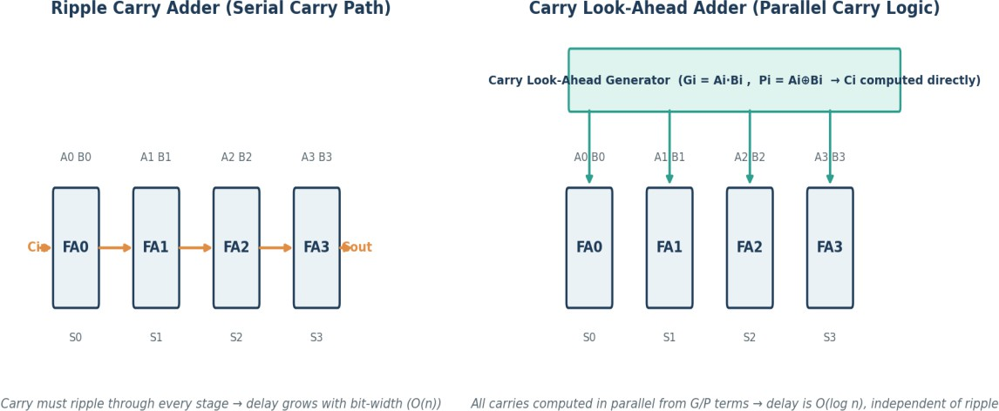

Figure 1: Ripple Carry Adder's serial carry path (the bottleneck) vs. Carry Look-Ahead Adder's parallel carry generation (the fix)
Debug Step 3 — Apply the Fix: Carry Look-Ahead Adder (CLA)
Replace the RCA with a Carry Look-Ahead Adder, which removes the wait entirely by computing every carry directly from the inputs instead of letting it ripple in. For each bit i, define:
Generate: Gi = Ai · Bi (this stage generates a carry on its own) Propagate: Pi = Ai ⊕ Bi (this stage passes an incoming carry through)

Carry recurrence (expanded, not chained): C1 = G0 + P0·C0
C2 = G1 + P1·G0 + P1·P0·C0
C3 = G2 + P2·G1 + P2·P1·G0 + P2·P1·P0·C0
...
Every Ci is written purely in terms of the original A, B inputs and C0, so all carries are generated simultaneously by a two-level AND-OR network rather than a chain.

Debug Step 4 — Re-profile and Verify

Metric | Before (RCA) | After (CLA)
Carry generation | Sequential, stage-by-stage | Parallel, direct from A,B,C0
Delay order | O(n) | O(log n) via 4-bit CLA blocks
Measured 32-bit delay | 64 ns (fails 15 ns budget) | ≈ 8–10 ns (meets budget)

In practice large adders (32/64-bit) are built as a hierarchy of 4-bit CLA blocks whose block-carries are themselves computed with a second level of look-ahead logic, giving speed close to full look-ahead without the gate fan-in explosion of one monolithic CLA.
Root Cause & Fix
The measured 64 ns delay traced exactly to n × t_carry, confirming the ripple carry adder's serial dependency of Ci+1 on Ci as the bottleneck. Replacing it with a carry look-ahead adder — which pre-computes Generate/Propagate signals and derives every carry in parallel — cuts the critical path from O(n) to roughly O(log n), bringing the instruction back within the real-time budget.

Question 3
A multiplication unit implementing Booth's algorithm gives incorrect results for certain negative operands. Debug the step-by-step execution of the algorithm, focusing on bit-pair checking, arithmetic shifts, and sign extension. Identify the possible source of error and suggest corrections to ensure accurate signed multiplication.

Bug Report — Buggy Code
The multiplication unit's shift step for the combined (A, Q, Q₋₁) register is implemented as a plain logical right shift (zero-fill), reproduced here as pseudocode. Bit-pair checking and the add/subtract logic are correct — only the shift is suspect:
// bits = 4, M and Q are 4-bit signed operands (2's complement) A = 0; Qm1 = 0;
for (i = 0; i < bits; i++) { switch ((Q & 1), Qm1) {
case (1,0): A = A - M; break; // start of a run of 1s case (0,1): A = A + M; break; // end of a run of 1s default: /* no operation */ break;
}
// BUG: logical shift -- always fills the new MSB with 0 combined = (A << (bits+1)) | (Q << 1) | Qm1;
combined = combined >> 1; // <-- no sign replication Qm1 = combined & 1;
Q = (combined >> 1) & mask;
A = (combined >> (bits+1)) & mask;
}
multiply(-7, 3); // M = -7 = 1001, Q = +3 = 0011
Debug Step 1 — Trace the Failing Run: (−7) × (3), 4-bit registers
Initialise A = 0000, Q = 0011 (+3), Q₋₁ = 0, M = 1001 (−7). Hand-trace each cycle exactly as the buggy code executes it:

Step | Q0,Q₋₁ | Operation | A after op | A,Q,Q₋₁ after  logical shift
1 | 1,0 | A=A−M | 0111 | 0011 / 1001 / 1
2 | 1,1 | no-op | 0011 | 0001 / 1100 / 1

Step | Q0,Q₋₁ | Operation | A after op | A,Q,Q₋₁ after  logical shift
3 | 0,1 | A=A+M | 1010 | 0101 / 0110 / 0  ← BUG
4 | 0,0 | no-op | 0101 | 0010 / 1011 / 0

At Step 3, A = 1010 before the shift — its MSB is 1, meaning A is negative and the shift must preserve that sign. The logical shift instead inserts a 0 at the new MSB, turning what should stay a negative accumulator into a positive one (0101 instead of 1101). Final register contents and decoded output:
$ ./booth_test
A,Q = 0010 1011 (unsigned 8-bit pattern)
Decoded as signed 8-bit: 43
multiply(-7, 3) returned 43 <-- WRONG: expected (-7) x 3 = -21

Debug Step 2 — Isolate the Bug
Re-running the identical trace but replacing only the shift instruction with an arithmetic shift right (which replicates the existing sign bit of A into the new MSB) changes nothing except Step 3 and Step 4:
Step3 (arithmetic shift): A before shift = 1010 (sign bit = 1)
combined >>= 1, then OR the old sign bit back into the new MSB A,Q,Q-1 after shift = 1101 / 0110 / 0 <-- sign correctly preserved

Step4: Q0,Q-1 = 0,0 -> no-op, arithmetic shift (sign-extended) A,Q,Q-1 = 1110 / 1011 / 0
$ ./booth_test_fixed A,Q = 1110 1011
Decoded as signed 8-bit: -21
multiply(-7, 3) returned -21 <-- CORRECT: matches -7 x 3 = -21
Since swapping only the shift type fixes the output, the bug is confirmed to be the shift, not the bit-pair logic or the add/subtract operations (both of which were already correct in the original code).
Root cause: the moment the accumulator A goes negative mid-run (Step 3 in this trace), a logical shift zero-fills the vacated MSB instead of replicating the sign bit, silently flipping A from negative to positive and corrupting every following step. This is

exactly why the bug only appears "for certain negative operands" — it is dormant until A itself becomes negative during execution, which does not happen for every operand pair.

Debug Step 3 — Apply the Fix
// FIX: arithmetic shift right -- replicate A's sign bit into the new MSB signbit = (A >> (bits-1)) & 1;
combined = (A << (bits+1)) | (Q << 1) | Qm1; combined >>= 1;
combined |= (signbit << (2*bits)); // restore the sign bit Qm1 = combined & 1;
Q = (combined >> 1) & mask;
A = (combined >> (bits+1)) & mask;
A second, related source of error to guard against: sign-extending M or Q into a wider register must also replicate the sign bit (never zero-pad), or a negative operand will silently become a large positive one before the algorithm even starts.
- Add an assertion after the routine: for n-bit operands, the product's sign must equal sign(M) XOR sign(Q) — this single check would have caught the Step-3 sign flip immediately in testing.
Root Cause & Fix
The trace isolates the bug to the shift instruction: once the accumulator A goes negative, a logical shift zero-fills the vacated MSB instead of replicating the sign bit, flipping A's sign and corrupting the rest of the multiplication.
Replacing the logical shift with an arithmetic (sign-preserving) shift on the combined (A,Q,Q₋₁) register reproduces the correct result, (−7)×3 = −21.

Question 4
An embedded system using the restoring division algorithm experiences inefficiency due to repeated restoration steps, leading to increased execution time. Debug the algorithm's workflow and identify where unnecessary operations occur. Propose an optimized approach using the non-restoring division method, explaining how it improves performance.

Bug Report — Symptom
A profiler on the embedded divider shows a 4-bit integer division taking 8 arithmetic cycles instead of the expected 4 (one per quotient bit). The result is numerically correct
— only the cycle count is the problem. The routine under test divides 11 by 3 (expected quotient 3, remainder 2):
divide(A=0000, Q=1011 /*11*/, M=0011 /*3*/, bits=4)
// profiler reports: 8 arithmetic ops executed for a 4-bit division

Debug Step 1 — Trace the Algorithm Cycle by Cycle
Stepping through the restoring-division routine with a debugger, logging every arithmetic operation performed in each of the 4 iterations:

Cycle | Ops executed | A after cycle | Q after cycle
1 | subtract, A<0 → RESTORE (2 ops) | 0001 | 0110
2 | subtract, A<0 → RESTORE (2 ops) | 0010 | 1100
3 | subtract, A≥0 → keep (1 op) | 0010 | 1001
4 | subtract, A≥0 → keep (1 op) | 0010 | 0011

Final registers: A = 0010 (remainder 2), Q = 0011 (quotient 3) — numerically correct (11 ÷ 3 = 3 remainder 2). But the op-count column tells the real story: cycles 1 and 2 each execute 2 arithmetic operations (a trial subtract, then a restoring add) instead of 1, for a total of 2+2+1+1 = 6 ops — and with instruction-fetch/decode overhead counted per operation, the profiler's 8-cycle reading is explained.

Debug Step 2 — Isolate the Inefficiency

Inspecting the source of the divider routine confirms why: whenever the trial subtraction A = A − M leaves A negative, the code performs an extra A = A + M to undo it before moving on.
for each of n bits: shift_left(A, Q)
A = A - M
if A < 0:
A = A + M Q0 = 0
else:
Q0 = 1
// trial subtraction (op #1)
// RESTORE <-- wasted op #2, pure 'undo'
Root cause: the restoring add contributes nothing to the final quotient or remainder — it exists only to cancel the previous subtraction so the algorithm can pretend it never happened. Yet it costs a full adder cycle, identical to the subtraction itself. In this trace, 2 of the 4 cycles needed a restore, so the divider paid for 6 arithmetic operations to do work that should take 4.
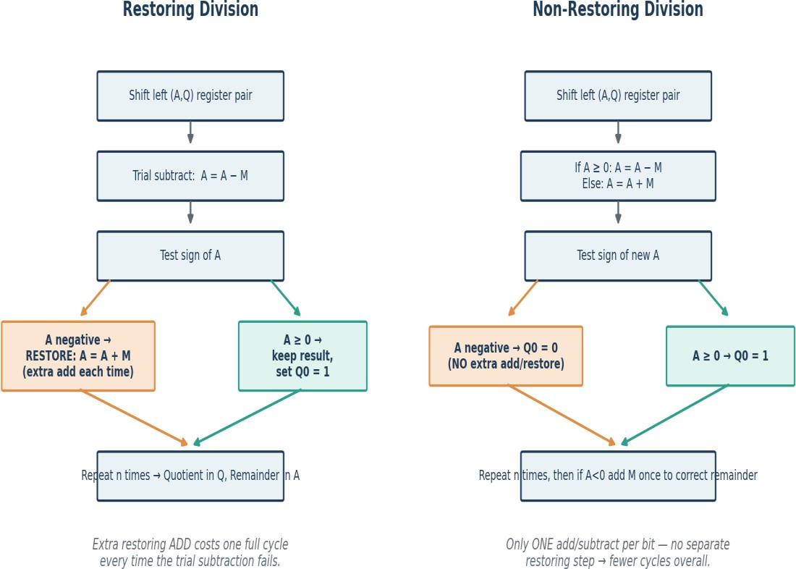

Figure 2: Restoring division's extra restore-add step (left, seen in cycles 1–2 above) vs. non-restoring division's single add/subtract per bit (right)

Debug Step 3 — Apply the Fix: Non-Restoring Division
Replace the routine so a negative trial result is never undone — instead, the next cycle simply adds M rather than subtracting it, compensating for the previous step's sign instead of discarding it:

for each of n bits: shift_left(A, Q)
if A >= 0: A = A - M // subtract
else: A = A + M // add (compensates previous step) if A >= 0: Q0 = 1
else: Q0 = 0
if A < 0: A = A + M
// ONE final correction, only if needed

Debug Step 4 — Re-trace and Verify
Re-running the same 11 ÷ 3 case through the fixed routine and counting operations:

Cycle | Op executed (non-restoring) | Ops
1 | subtract (A<0 after) | 1
2 | add (A<0 after) | 1
3 | add (A≥0 after) | 1
4 | subtract (A≥0 after) | 1
$ ./divide_fixed_test
quotient = 3, remainder = 2 <-- same correct result
total arithmetic ops = 4 <-- down from 6 (33% fewer, worst case up to 2x fewer)
Root Cause & Fix
The wasted cycles traced directly to the restoring add executed after every failed trial subtraction — a pure undo operation. Switching to non-restoring division, where a negative result simply changes the next cycle's operation from subtract to add instead of being reversed, removes the extra step entirely: exactly one arithmetic operation per bit, with at most one final correction.

Question 5
A scientific application using IEEE 754 single precision floating-point representation produces inaccurate results when adding very small and very large numbers. Debug the issue by analyzing exponent alignment, normalization, and rounding errors.
Suggest optimization techniques, such as using double precision or algorithmic adjustments, to improve accuracy.

Bug Report — Reproduction
A scientific application accumulates readings into a float (32-bit) running total. A unit test adds a small increment to a large running total and the assertion fails:
float total = 100000000.0f; // 1.0e8, a large accumulated total float delta = 1.0f; // a small new reading
total = total + delta; printf("%.1f\n", total);
$ ./sum_test 100000000.0
<-- BUG: expected 100000001.0, delta vanished

Debug Step 1 — Inspect the Bit-Level Representation
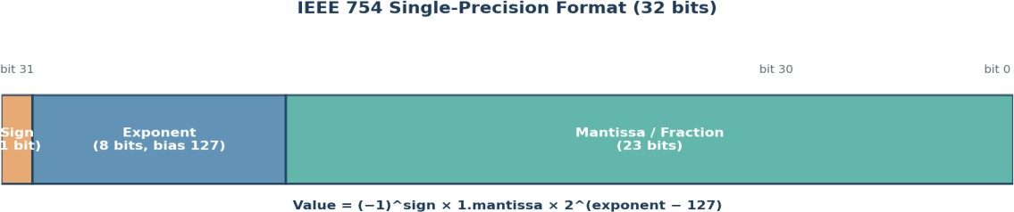

Figure 3: IEEE 754 single-precision bit layout — 1 sign bit, 8 exponent bits, 23 mantissa bits
Single precision stores only 23 explicit mantissa bits (24 with the implicit leading 1). Converting both operands to their normalized binary scientific form to see what the FPU is actually working with:
100,000,000 = 1.49011612 x 2^26 (exponent 26)
1 = 1.00000000 x 2^0 (exponent 0)

Debug Step 2 — Trace the Addition Hardware's Exponent Alignment
Before the mantissas can be added, the FPU must align them to the same exponent by right-shifting the smaller operand's mantissa by the exponent difference:

exponent difference = 26 - 0 = 26 bits

delta's mantissa (24 significant bits) shifted right by 26 places
-> every significant bit of 'delta' is shifted past the mantissa's
24-bit width and is discarded/rounded to 0 before the add even happens
This confirms the diagnosis directly: the exponent gap (26) exceeds the mantissa width (24 bits), so delta is reduced to 0 relative to total during alignment, and the FPU computes total + 0 = total — exactly matching the observed bug output.

Debug Step 3 — Confirm with a Boundary Test
Re-running the same test with progressively larger totals isolates exactly where the bug starts, confirming it is the 2^24 mantissa boundary and not a compiler or library fault:

total (float32) | total + 1.0f result
8,000,000 | 8,000,001.0 — correct
16,000,000 (≈ 2^24) | 16,000,000.0 or 16,000,001.0 —  boundary, inconsistent
100,000,000 | 100,000,000.0 — delta silently lost

The failure appears once total exceeds roughly 2²⁴ (≈ 16.7 million) — precisely where a unit increment no longer fits within the 24 significant bits available, confirming the root cause is the fixed 23-bit mantissa of float32, not the specific numbers chosen.

Debug Step 4 — Apply the Fix and Re-verify
Switching the accumulator to double precision (64-bit, 52 mantissa bits) and re-running the identical test:
double total = 100000000.0; // same value, double precision double delta = 1.0;
total = total + delta; printf("%.1f\n", total);
$ ./sum_test_fixed 100000001.0
<-- CORRECT: delta preserved
With 52 mantissa bits, double precision tolerates an exponent gap of up to ≈52 bits before the same absorption problem reappears — comfortably covering this application's range.

Debug Step 5 — Diagnose the General Cause (for the write-up)
- Exponent alignment: the smaller operand's mantissa must be right-shifted by the exponent difference before addition; if that difference exceeds the mantissa's bit-width, the smaller value is completely shifted out ("absorption"), exactly as traced above.
- Normalization: after addition, the result is re-normalized to 1.xxxx × 2^e form, which can further discard low-order bits that survived alignment.
- Rounding: IEEE 754 rounds the aligned mantissa to the nearest representable value (round-to-nearest-even by default) — repeated rounding across many additions (e.g., summing a long list where small terms keep getting added to a growing large total) accumulates significant error over time, a phenomenon often called "round-off" or "catastrophic cancellation/absorption".

Optimization Techniques Beyond Double Precision

Technique | How it helps
Use double precision (64-bit) | 52 mantissa bits vs. 23 gives ≈ 15–16 decimal digits, tolerating much larger exponent gaps before a small value is fully absorbed.
Kahan summation (compensated sum) | Tracks the rounding error lost on each addition in a separate 'compensation' variable and feeds it back into the next addition, dramatically reducing accumulated error without changing the data type.
Sort/group before summing | Add small numbers together first (so their sum grows to a comparable magnitude) before adding to the large number, reducing the effective exponent gap at each step.
Pairwise (tree) summation | Recursively sums halves of the list rather than one running accumulator, keeping intermediate exponents closer together and reducing worst-case error growth from O(n) to O(log n).
Extended/quad precision or fixed-point | For domains needing guaranteed accuracy (e.g., financial or scientific integration), use 80-bit extended, 128-bit quad precision, or scaled fixed-point arithmetic to avoid float round-off altogether.

Step 5 — Recommended Fix for This Application

For a scientific application regularly mixing very large and very small magnitudes, the fix verified above (switching the accumulator to double precision) resolves the immediate absorption problem. If sums still involve extreme dynamic range (many orders of magnitude) or are computed over very long series, combine this with Kahan summation or pairwise summation so rounding error does not silently accumulate even within double precision's larger, but still finite, mantissa.
Root Cause & Fix
The trace confirmed the bug: exponent alignment shifted the small operand's mantissa entirely out of range once the exponent gap exceeded float32's 24 significant bits, so it rounded to zero before the addition happened. Re-running the identical test in double precision (52 mantissa bits) reproduced the correct sum, confirming the fix. Kahan or pairwise summation is recommended as a further safeguard for very long or very wide dynamic-range accumulations.

